Sign Off
Walk-Though | Held On: | Document Version:
Decision | Accept as-is  Revise – no further Walk-Through required  Revise and schedule another Walk-Through

Role | Name of Attendee filling role at Walk-Through | Sign-Off (Content Review and Approval) | Date
Application Analyst
Architect
Business Analyst
Business Lead
Business Sponsor
Development Lead
Development Manager
Division Information Security Officer
Program Manager
Project Manager
Release Manager
Technical Lead

This document has these primary purposes:
- Determine which systems and applications need to be involved in the project / ITR
- Evaluate the impact to the involved systems and applications
- Create a To-Be System and Application blueprint that allocates the proposed solution across the involved systems and applications
- Ensure solutions are consistent with the division’s Standards, Roadmaps, and Strategies
- Communicate architecturally significant decisions to project stakeholders

This document should be filled out whenever the work crosses systems or applications including the times where the only impact is to identify testing needs. There is one and only one System Architecture Specification for each Project or Release Feature. See LDM Sizing Guidelines for more information.

Signature indicates receipt of document. Initialing “Content Reviewed & Approved” indicates understanding and acceptance of material.

Please reference LDM Roles on LIDI for details of who uses this document and why

Revision History
Revision # | Date | Description | Author
1.1
1.0
0.1
[Note to Author:
The Revision History is maintained once the document is signed off. Prior to signoff, changes to the document do not need to be tracked here, however, any changes to the document require a new version to be saved. Place most current version first. The list is in descending order.]

Table of Contents
Sign Off 1
Revision History 2
Table of Contents 2
Architectural Goals & Guidelines 3
Cross System & Application Architecture 4
“As-Is” 5
Diagram 5
Description 6
“To-Be” 7
Diagram 7
Description 8
Architecture Impact and Solution Allocation 9

Architectural Goals, Drivers, & Guidelines

[Note to Author:
Describe any goals, guidelines, principles, or priorities, which dominate or influence the design. These can come from a variety of sources including the Division’s overall business strategy, portfolio strategy, technology strategy, Application and Technology Standards, and Technology and Application guidelines.
Examples: KISS, Emphasis on speed or simplicity, working, looking, or “feeling” like an existing application.
For each describe the reason for its importance and cite the source.
Reference specific design drivers from relevant Application and Technology Roadmaps, ITS projects and directions, and other IT Strategies that are influencing the design.
The associated Application Design Specifications should keep these Goals, Drivers, & Guidelines in mind when working out their designs.]

Cross System & Application Architecture
[Note To Author:
This section represents the top level view of the systems in use currently and in the future as a result of proposed changes. The As-Is view will be used to analyze system and application interactions and impacts. The To-Be view will be the basis of the solution allocation.. Both the As-Is and To-Be diagrams should include all systems/applications internal and external that are involved and their location in security zones (DMZs). Additionally the protocols and ports required for communication should be shown. NB. If this proves impractical in this view it must be done in the Physical Architecture diagram in the Application Design Specification.
Where complexity merits, this section may need to be separated into a high level system interaction and subsequent application interaction diagrams. The application interaction diagrams must maintain the interface lines shown on the system level view. The sizing discussion in planning and analyze will determine how many diagrams need to be produced and will assign responsibility for each.]

“As-Is”

Diagram
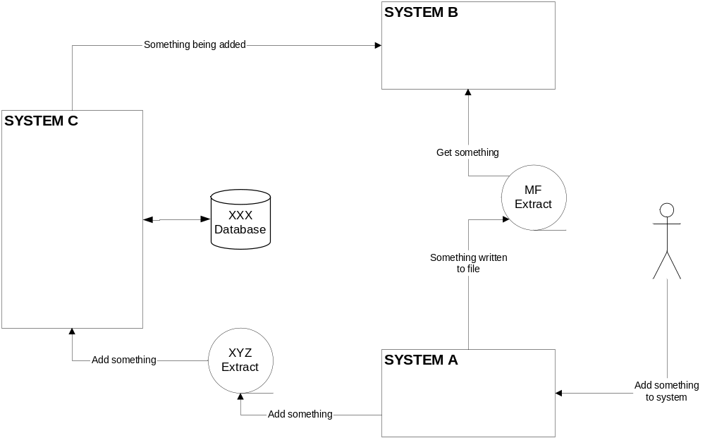
Figure 1: Architecture Overview As-Is
[Note To Author:
Provide a graphical view of interactions between systems/applications, as they exist today. Use Smart Diagramming / Visio. A system is defined as an application, such as ADMS, Cyberlife or Pivotal, or a group of related applications that are acting together to perform a business function, such as Filenet, Worksheet and IPD when talking about workflow.
The purpose of this activity is to gather enough information to make a reasonable assessment of the current behaviors and interactions in order to identify the key groups and systems to involve in the “To Be” view and to provide budget/analytical input.
Only Systems, Corporate/Shared Databases, Shared Files, Mainframe extracts, and interface flows are described. Internal application pieces are described in the architecture section of the Application Requirements.]

Description

[Note To Author:
This is the process view referencing the above Diagram. Provide a general description of Systems and Applications and the flow of information among them.
Do not describe things within or encapsulated by applications.
Incorporate Use cases and/or Business Rule Scenarios to illustrate the flow of information with examples whenever possible. Also be sure to describe what type of interaction you are referencing (e.g., Batch, Online, Synchronous, Asynchronous, etc..]

“To-Be”

Diagram
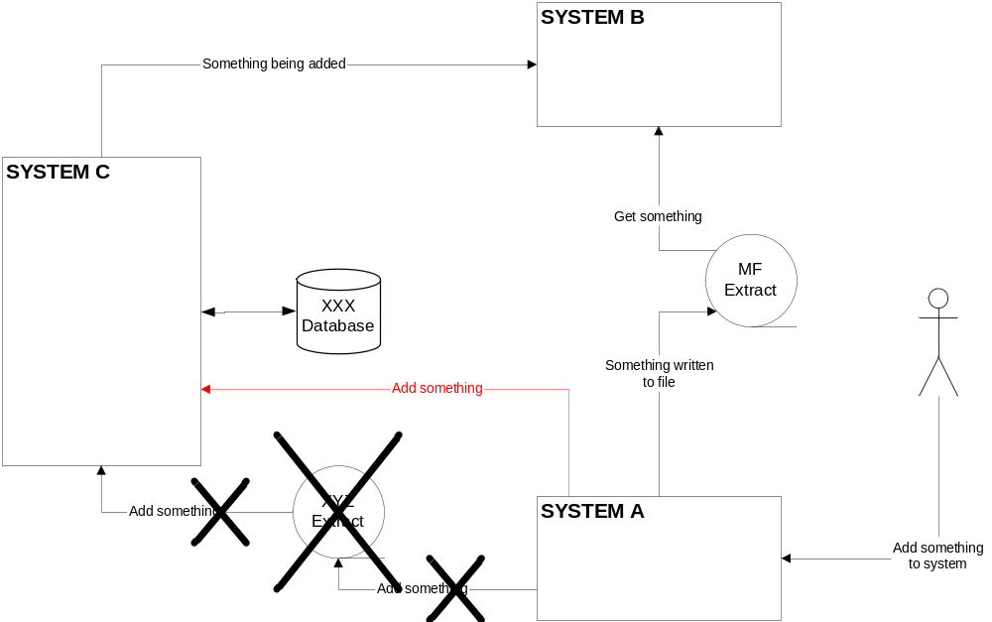
Figure 1: Architecture Overview To Be
[Note To Author: Provide a graphical view of the proposed interactions between systems/applicaitons. All existing systems interfaces remain on the diagram with those being removed denoted either by graying-out or x-ing out.
Add
- New systems or applications
- New Interfaces
- New databases
- New CICS regions
- New vendors.
Note changes to any existing elements.
The purpose of the “To Be” view is to establish the scope of the change request and a common reference point for each application group. The application groups will utilize this common viewpoint to identify their key system impacts and provide a high-level budget estimate. This view will also serve as a common starting point for project development and future analysis stages.
Only Systems, Corporate/Shared Databases, Shared Files, Mainframe extracts, and interface flows are described. Internal application pieces are described in the architecture section of the Application Requirements.]

Description

[Note To Author:
This is the process view referencing the above Diagram. Provide a general description of Systems and Applications and the flow of information among them.
Incorporate Use cases and/or Business Rule Scenarios to illustrate the flow of information with examples whenever possible. Also be sure to describe what type of interaction you are referencing (e.g., Batch, Online, Synchronous, Asynchronous, etc..]

Architecture Impact and Solution Allocation
Application / System | Input | Process | Output
System A | - No Change | - Will no longer produce XYZ extract  - Will use EAI to talk to System B | - No longer produce XYZ Extract
System B | - Will no longer take input when something added from XYZ extract | - Need to accept input from EAI process | - No Change

[Note To Author :
In this section the changes or “impact” to each system/application, outlined in the “To Be” diagram will be described. Brief functional statements on the processing and interface changes to each system/application are described. This section supports the “To Be” diagram by providing greater descriptive information on the flow of data processing logic that will be required to satisfy the business request.
Look at each change from three perspectives:
Inputs
Describe any changes to the inputs to the process. Include additions and deletions. Note changes to volumes or number of system users.
E.g. System A will now automatically receive input from System D. There is no longer a need to manually input data from System D.
Any other impacts to inputs
Process
Describe any changes to the processing performed. Note changes to volumes, batch processing times or windows.
E.g. Will no longer produce XYZ extract. Will use EAI to talk to System B
Any other impacts to process
Outputs
Describe any changes to the outputs from the process. Include additions and deletions. Note changes to volumes.
Describe any changes to the outputs produced by the process. Include additions and deletions.
E.g. No longer produce XYZ Extract
Any other impact to output
In the Application Requirements each application impacted by the change will expand the Architectural To-Be View and this description with functional detail particular to the impacted application and will describe the particular requirements for the impacted application components.
This section should provide a high-level overview of how the functionality and responsibilities of the system are portioned and then assigned to applications. Describe the major responsibilities that the system/application must undertake and the various roles that the system or parts of the system must play.
Describe any significant change in number of users, volumes, response time, or end to end processing time
List each change or impact as a separate bullet]

